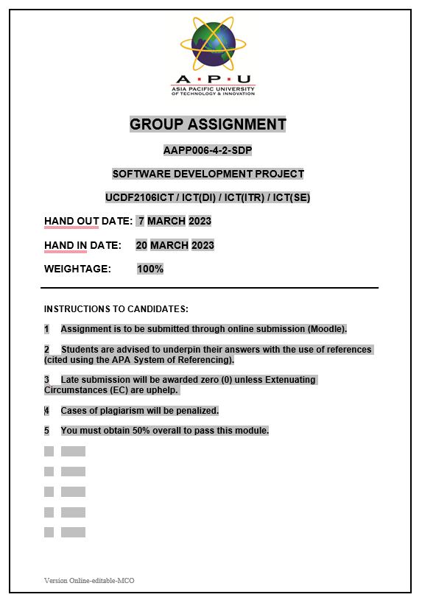



**Software Development Project – Cover Sheet**

ASSIGNMENT

**Instruction:**

* Marks will be awarded for good presentation and thoroughness in your approach.
* Referencing Code: If you use some code, or ideas for code, which are taken or adapted from another source (book, magazine, internet, discussion forum, etc), then this **must** be cited and referenced using the APA convention within your source code. Failure to reference code properly is considered as plagiarism.
* Complete this cover sheet and attach it to your project first page.
* This project is to be attempted by a group of 5 students.

|  |  |  |  |  |
| --- | --- | --- | --- | --- |
| **Student declaration:** | | | | |
| *I declare that:* | 1. *We understand what is meant by plagiarism* 2. *The implication of plagiarism have been explained to us by our lecturer* 3. *This project is all our work and we have acknowledged any use of the published or unpublished works of other people.* | | | |
| Group Leader’s Signature: | | | Date: | |
|  | | |  | |
| **Project Title:** | | | **Intake:** | |
| **Name** | | | **Signature** | |
|  | | |  | |
|  | | |  | |
|  | | |  | |
|  | | |  | |
|  | | |  | |